Project No 48 Estonian Latvian Entrepreneurs cooperation platform
Program me
Experience exchange visit for Estonian entrepreneurs
5 – 6 October, 2017
and
Seminar for Estonian and Latvian entrepreneurs
5 October, 2017

The First Day - 5 Oktober

11:00– 12:00 | Lamprey fishing and processing LTD „Krupis”  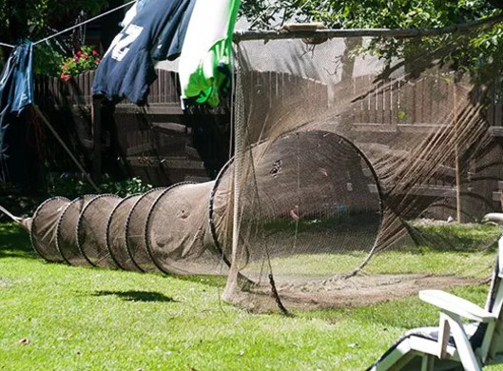  Zvejnieku iela 22, Carnikavas novads Coffee and lamprey tasting
12:00 -13:00 | Carnikava Local History Museum  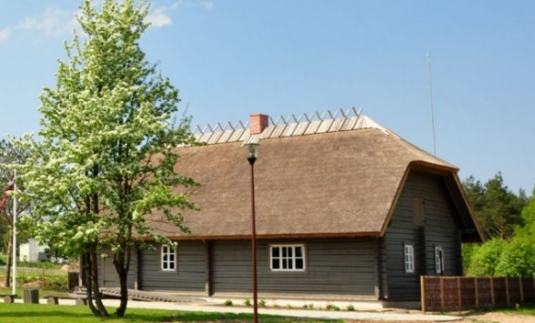
13:30 –  14:30 | Lunch  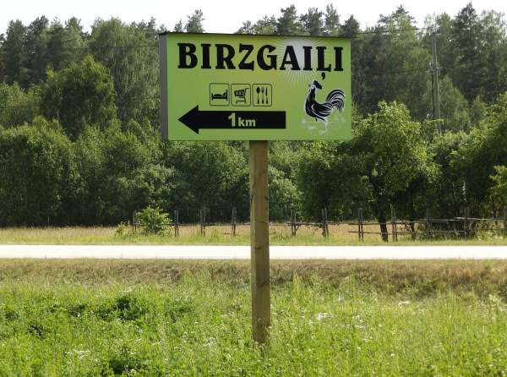  Place of implementation of various LIDER projects, related to the diversification of leisure activities
14:45 | Peat extraction and processing company LTD "Lauga"  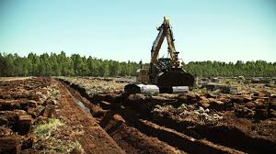
16:00 – 16:30 | Arrival in the guesthouse "Vecmuiža" and coffee  http://vecmuiza.lv/ Zaķi, Liepupes pag., Salacgrīvas novads
16:30 – 19:00 | Workshop for Latvian and Estonian entrepreneurs  - Information about planed project activities Anneli Roosalu  - Cooperation between Municipality and entrepreneurs. Chairman of Salacgriva County Council Dagnis Straubergs.  - Coastal business importance for smart development Edgars Pudzis Riga Technical University  - Discussion - to initiate cross-border cooperation between entrepreneurs- to get new ideas.
19:30 | Dinner
The Second Day 6 Oktober

08:30 – 09:30 | Breakfast
10:00 – 11:00 | Arnis Preiss Ceramic workshop and bee products  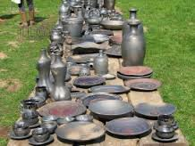  (degustation)
11:30 – 13:00 | Domestic producer of meat SIA “Bišu zeme”  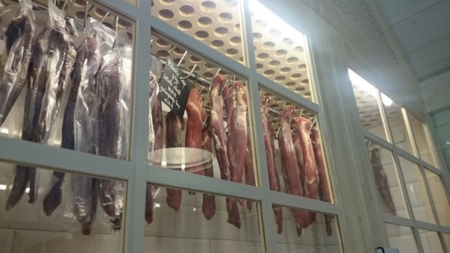(Degustation)
13:30 – 15:00 | Co-working space “Ņirbulis” in Salacgriva  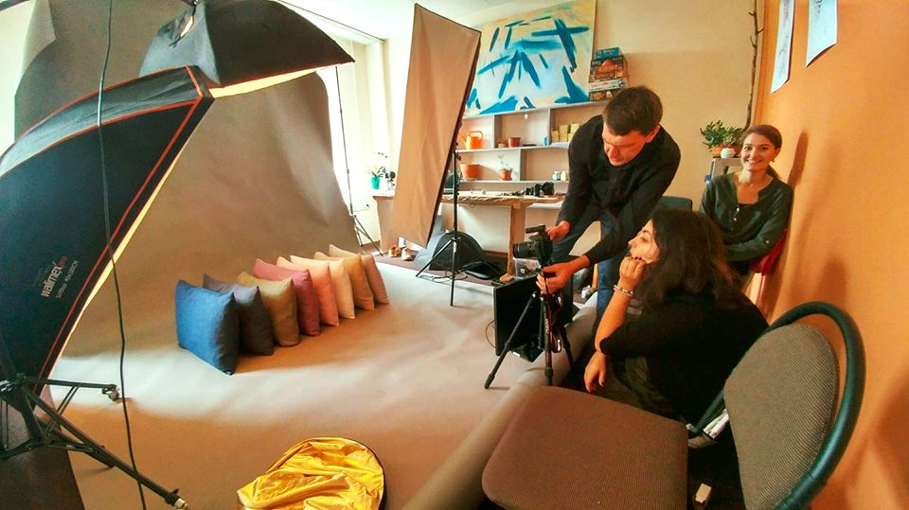
15:00 –  16:00 | Fishing farm with an additional offer for tourists “J.A.K.I.” (Lunch - Salmon soup made on campfire)  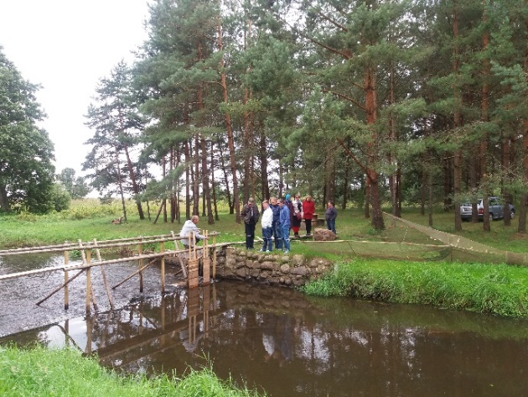
16:00 | Marketing center “Made in Salacgriva”  